Instructions for Preparing Papers for the Journal of Artificial Intelligence Applications and Data Science (JAIADS)
Aaa Surname^{a,*}, Bbb B. Surname^{b}, Ccc C.C. Surname^{b,c}
ORCID iDs: Aaa Surname 0000-0000-0000-0000 · Bbb B. Surname 0000-0000-0000-0000 · Ccc C.C. Surname 0000-0000-0000-0000
ª Department, Institution, Full Postal Address, City, Postal Code, Country
^{b} Department, Institution, Full Postal Address, City, Postal Code, Country
^{c} Department, Institution, Full Postal Address, City, Postal Code, Country
* Corresponding author: corresponding.author@institution.edu.iq
ARTICLE INFO | ABSTRACT
Article type: Research Article  https://doi.org/10.XXXXX/jaiads.XXXX  Received: DD Month YYYY  Revised: DD Month YYYY  Accepted: DD Month YYYY  Available online: DD Month YYYY  Handling editor: to be completed by the editorial office  Keywords:  keyword 1, keyword 2, keyword 3, keyword 4, keyword 5, keyword 6  (alphabetical order; maximum 8; use widely recognised terms to maximise indexing visibility) | Background / Objective: State the research problem, the gap in the literature, and the specific objective(s) of the study in 2–3 sentences. Do not cite references in the abstract.  Methods: Summarise the dataset(s), the models or algorithms, the evaluation protocol, and the statistical or experimental design in 2–4 sentences. Name the reproducibility-relevant choices (architecture, key hyper-parameters, dataset version, validation scheme).  Results: Report the principal quantitative findings — accuracy, F1, AUC, RMSE, p-values, effect sizes, confidence intervals — and how they compare with the baselines or with prior work. Use 2–4 sentences.  Conclusions: State the main contribution, its significance, and its scope of applicability. Mention one principal limitation.  Total abstract length: ≤ 250 words. Unstructured abstracts are accepted only for Review and Perspective articles.

1. Introduction
Throughout the main text please follow these prescribed settings: (1) the body font is Times New Roman; (2) all body text is set in 10 pt; (3) line spacing is single throughout; (4) leave 10 pt of vertical space above and below every heading, equation, figure and table caption.
This template is pre-formatted. Replace the placeholder text without changing fonts, sizes, spacing, margins or section order. The header and footer are pre-populated with placeholders and are completed by the typesetter — please do not edit them.
The Introduction of your own manuscript should establish the problem, review the relevant literature critically rather than descriptively, state the gap the work addresses, and close with an explicit list of contributions. A closing paragraph outlining the organisation of the paper is optional and should be kept to two sentences.

2. Manuscript Types, Structure and Length

2.1 Accepted article types
JAIADS accepts four article types. State the type on the title page and in the submission system.
Table 1. Article types, length limits and abstract requirements
Article type | Maximum length | Abstract | References
Research Article | 10 pages | Structured, ≤ 250 words | 30–60
Review Article | 16 pages | Unstructured, ≤ 300 words | 80–150
Short Communication | 5 pages | Unstructured, ≤ 150 words | ≤ 25
Perspective / Editorial | 4 pages | Unstructured, ≤ 150 words | ≤ 20

2.2 Required section order
Research Articles must follow this order: Abstract; 1. Introduction; 2. Related Work; 3. Materials and Methods (dataset, pre-processing, model, training protocol, evaluation metrics); 4. Results; 5. Discussion; 6. Conclusions. Results and Discussion may be merged if the argument requires it, but Conclusions must remain a separate section. Sections 2 to 8 of this template are instructions and are replaced by your own content.
The back matter that follows the Conclusions is mandatory and must appear in the order given in this template: CRediT author statement, Declaration of Competing Interests, Funding, Ethics Approval, Data Availability, Code Availability, Use of Generative AI, Acknowledgments, References. Nomenclature, Appendix and Author Biographies are optional.

3. Page Setup
The page size is A4 (8.27 in × 11.69 in) with 2 cm margins on all sides. Do not change the page settings supplied with this template.
Manuscript length is counted from the title to the last reference, inclusive of figures and tables, and must not exceed the limit for the article type in Table 1. Do not insert page numbers, and do not edit the header or footer — both are reserved for technical editing by the editorial office.

4. Section Headings
Three heading levels are permitted. Use formal decimal numbering throughout (1, 1.1, 1.1.1). No further subdivision is allowed.
Level 1 (e.g., 4. Section Headings): Times New Roman, 10 pt, bold, small capitals, 20 pt before and 10 pt after.
Level 2 (e.g., 4.1 Sub-heading): Times New Roman, 10 pt, bold, sentence case, 10 pt before and after. When a Level 2 heading falls directly under a Level 1 heading, leave only 10 pt above.
Level 3 (e.g., 4.1.1 Sub-sub-heading): Times New Roman, 10 pt, bold italic, sentence case, 10 pt before and after.
Do not begin a new section at the foot of a page. If there is no room for at least two lines of body text below the heading, force the heading to the top of the next page.

5. Author Information

5.1 Names and letter superscripts
Provide full first names; middle names may be abbreviated. Match authors to affiliations with letter superscripts (a, b, c, …) rather than numerals — letters avoid visual collision with bracketed reference numerals such as [1], [2]. Author order is fixed at acceptance and cannot be changed at proof stage without a signed request from every author.

5.2 ORCID iDs (mandatory)
Every author must supply a valid 16-digit ORCID iD. Submissions without an ORCID iD for the corresponding author are returned at desk review. List the iDs on a single line beneath the author names, in the same order as the authors.

5.3 Affiliations
Each affiliation occupies its own line, in 9 pt italic, with the matching letter superscript, and must include the department or unit, institution, full postal address, city, postal code and country. Incomplete affiliations cause failures in Scopus author-profile normalisation. If several authors share one affiliation, list it once and give it all the relevant superscripts.

5.4 Corresponding author
Denote the corresponding author with an asterisk immediately after the affiliation superscript (e.g., Surnameᵃ,*). Give the institutional email beneath the affiliation block; personal webmail addresses are not accepted. Co-author emails may be supplied during review, but only the corresponding author's email is published.

6. Mathematics, Units and Numbers

6.1 Equations
(1) Tool. Use the native Microsoft Word equation editor or MathType. Do not paste equations as images — image equations cannot be indexed, cannot be read by screen readers, and will be returned for re-keying. "Float over text" must not be selected.
(2) Format. Equations are set in 10 pt with 10 pt of space above and below, flush left, without indentation.
(3) Numbering. Number every equation consecutively and place the number flush right in round brackets. Refer to equations in the text as Eq. (1) and Eqs. (2)–(4). Define every symbol at first use.
ℒ(θ) = − (1/N) Σi=1..N [ yi log ŷi + (1 − yi) log(1 − ŷi) ] + λ‖θ‖² | (1)

6.2 Measurement units and numbers
Use SI units wherever possible. Where an application domain widely uses different units, minimise the use of non-standard units and symbols. For example, "y" is preferred to "a" for year, "h" to "hr" for hour, and "t" to "ton" or "tonne". Case matters: "Km" does not mean kilometre, it means kelvin-metre.
Leave a regular or non-breaking space between a numerical value and its unit; this includes the litre, which is capitalised as "L". No space is used before the percent sign or the degree Celsius symbol (e.g., 35%, 234°C).
Use the dot as the decimal separator and the comma as the thousands separator — 1,000,000, not 1000000 or 1 000 000. Report computational cost in the conventional units of the field (GFLOPs, parameter count in millions, GPU-hours).

6.3 Statistical reporting
Report a measure of dispersion with every performance figure — standard deviation over repeated runs, or a confidence interval. A single-run number with no dispersion is not an acceptable basis for a comparative claim. State the number of runs and the seeds. Where two systems are compared, report a significance test appropriate to the design and give the exact p-value rather than a threshold.

7. Tables and Figures

7.1 General
(1) Give every table a brief descriptive title above it, and every figure a caption below it. Do not embed captions inside the figure graphic or in linked text boxes, and do not place a border around a figure.
(2) Table titles and figure captions are centred, Times New Roman, 10 pt. Capitalise only the first letter of the caption and any proper nouns.
(3) Refer to every table and figure in the text before it appears, written in full — Table 1, Figure 1 — not Tab. 1 or Fig. 1. Place each table and figure as close as possible to its first mention, at the top or bottom of the page.
(4) Leave 10 pt between a table title and its table, between a figure and its caption, and between a table or figure and the text that follows.
(5) Figures must be legible in greyscale and must not rely on colour alone to distinguish series; use line style or marker shape as well. Do not use rainbow colour maps for continuous data.

7.2 Tables
Table text is set in 9 pt and the table number is bold. Use horizontal rules only — no vertical rules and no full grids. Highlight the proposed method in bold so the reader can locate it at a glance.
If a table is too long for one page, repeat the table number and heading on the following page before continuing it. Alternatively, spread the table over two facing pages turned through 90°, without repeating the heading.

Table 2. Classification performance on the held-out test set (mean ± SD over five seeds)
Model | Accuracy | Macro-F1 | AUC | Params (M)
Logistic regression (baseline) | 0.812 | 0.784 | 0.869 | 0.01
ResNet-18 | 0.901 ± 0.008 | 0.887 ± 0.010 | 0.943 | 11.2
Proposed model | 0.928 ± 0.006 | 0.919 ± 0.007 | 0.961 | 8.4
Notes: 1. Use 8 pt for table notes. 2. Number multiple notes 1, 2, 3 … and separate them with a semicolon. 3. Align the left and right edges of the note area with those of the table above it. 4. Distribute notes evenly between the margins.

7.3 Figures
Keep each caption on the same page as its figure and, preferably, on a single line. If the caption is a complete sentence, close it with a full stop; if it is not, use no terminal punctuation.
Figures and captions are centred. Every word, number, shape and symbol must remain discernible at 120% page zoom. Supply vector graphics (EPS, PDF, SVG) where the figure is a plot or diagram, and at least 300 dpi where it is a photograph or a raster medical image. Use Times New Roman, Arial, Helvetica, Cambria or Symbol for text inside figures. Two examples follow; note the spacing allowed in each case.

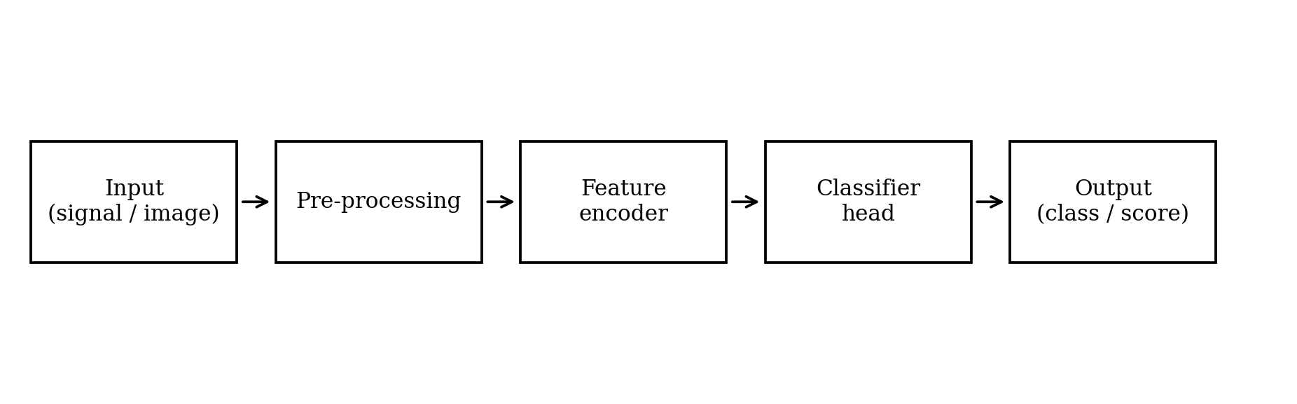
Figure 1. Block diagram of the proposed processing pipeline
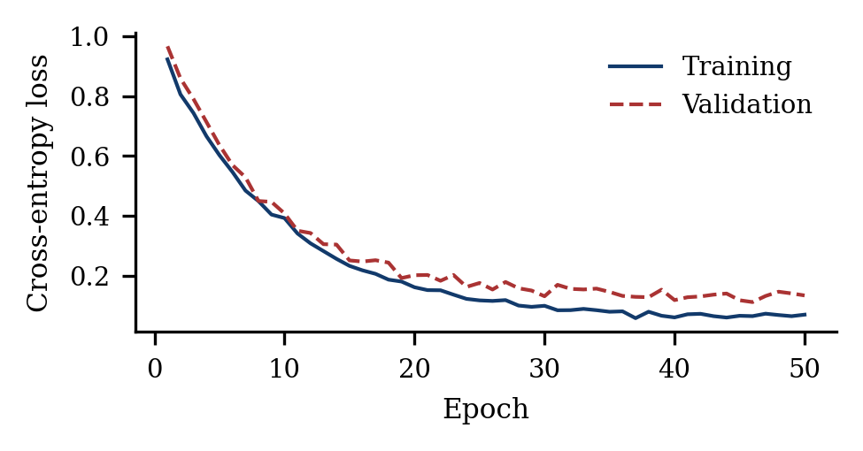
(a) Learning curves
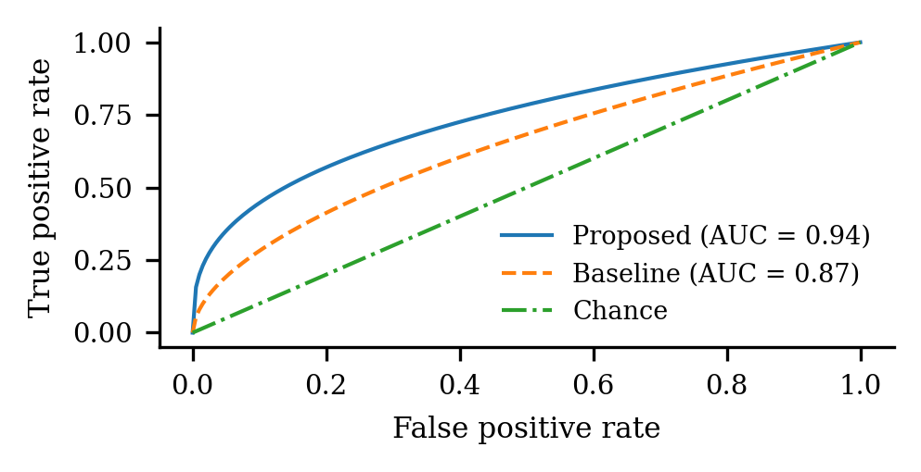
(b) Receiver operating characteristic
Figure 2. Training behaviour and discrimination of the proposed model against the baseline

8. Reproducibility and Reporting Requirements
JAIADS applies a reproducibility standard to every empirical submission. The items below are checked at desk review; a manuscript that omits them is returned to the authors before peer review begins.
- Data. Name every dataset with its version or release date, its licence, and its provenance. Give the number of samples per class and the exact train / validation / test split, including whether the split is subject-wise, patient-wise or random.
- Pre-processing. Report resampling, normalisation, augmentation and class-balancing steps in enough detail to be re-implemented, and state that they were fitted on the training partition only.
- Model and training. Report architecture, parameter count, loss, optimiser, learning-rate schedule, batch size, epochs, early-stopping rule and regularisation. State how hyper-parameters were selected and over what search space.
- Randomness. State the number of independent runs and the seeds, and report mean and dispersion for every headline metric.
- Compute. State hardware, software versions (framework and CUDA), training time and inference latency.
- Metrics. Justify the choice of metric for the class balance at hand. Accuracy alone is not acceptable for imbalanced problems; report macro-F1, balanced accuracy, AUPRC or an equivalent.
- Baselines. Compare against at least one competitive published method under an identical protocol, not against figures quoted from another paper's different split.
- Clinical and human-subject work. Report subgroup performance where the sample allows it, and state the intended deployment setting and the risks of failure.

Where a constraint prevents an item from being met — a licence that forbids data release, a proprietary clinical cohort — state the constraint explicitly in the Data Availability statement rather than omitting the item silently.

9. Conclusions
State the main conclusions of the work, the significance of the findings and their scope of applicability. Acknowledge at least one principal limitation and indicate concrete directions for future work. The Conclusions section is mandatory; it must not duplicate the Abstract and must not introduce results that do not appear in the body of the paper.

CRediT Author Statement
Use the fourteen-role Contributor Roles Taxonomy. List each author and their roles using the standard verbs: Conceptualization; Methodology; Software; Validation; Formal analysis; Investigation; Resources; Data curation; Writing — original draft; Writing — review & editing; Visualization; Supervision; Project administration; Funding acquisition.
Aaa Surname: Conceptualization, Methodology, Writing — original draft. Bbb B. Surname: Software, Validation, Formal analysis. Ccc C.C. Surname: Supervision, Writing — review & editing, Funding acquisition.

Declaration of Competing Interests
The authors declare that they have no known competing financial interests or personal relationships that could have appeared to influence the work reported in this paper. Where competing interests exist, declare them in full here. This declaration is mandatory; manuscripts without it are returned at desk review.

Funding
State all sources of funding by name, including grant numbers (e.g., "This work was supported by the National Science Foundation under Grant No. XXXX-YYYY"). If the work received no specific funding, state: "This research did not receive any specific grant from funding agencies in the public, commercial, or not-for-profit sectors."

Ethics Approval and Informed Consent
If the study involves human participants, animal subjects, or human-derived data, give the name of the approving ethics committee, the protocol number and the date of approval, and confirm that informed consent was obtained where applicable. For retrospective work on de-identified records, state the waiver and the authority that granted it. If none of this applies, state "Not applicable."

Data Availability Statement
Specify where all data supporting the findings can be found, with a permanent identifier. Acceptable repositories include Zenodo, Figshare, IEEE DataPort, Mendeley Data and recognised discipline-specific archives. Example wording:
"The dataset(s) supporting the conclusions of this article are available in the [repository name] repository, https://doi.org/10.XXXX/zenodo.XXXXXXX. Restricted-access datasets must declare the access procedure and the contact person."

Code Availability Statement
All code supporting the results — training scripts, evaluation pipelines and pre-trained weights — must be available with a permanent DOI. A GitHub link without a Zenodo (or equivalent) DOI snapshot is not sufficient for indexing. Example wording:
"All source code and trained model weights are available at https://github.com/[org]/[repo] and archived at https://doi.org/10.5281/zenodo.XXXXXXX (release v1.0). The code is released under the [MIT / Apache-2.0 / GPL-3.0] licence."

Use of Generative AI in the Writing Process
Disclose any use of generative AI or large language models in preparing the manuscript, naming the tool, the version and the purpose (e.g., "Claude (Anthropic) was used for language editing of Sections 2 and 4. The authors reviewed and edited all output and take full responsibility for the content."). LLMs cannot be listed as authors. Use of generative AI to produce or alter research data, figures or images is not permitted. If no such tools were used, state: "The authors declare that no generative AI or LLM tools were used in the preparation of this manuscript."

Acknowledgments
Acknowledge non-author contributors, technical assistance and access to facilities. Avoid first-person constructions ("One of us would like to thank …"). Use a single Acknowledgments heading even where there are several distinct acknowledgments.

References
JAIADS uses the IEEE numeric reference style. Cite references in the text in square brackets in order of first appearance — [1], [2], [3]–[5] — not as superscripts. Every reference with a DOI must include it as a clickable hyperlink. Use a reference manager (Zotero, Mendeley, EndNote); IEEE .csl and .ens style files are available on the journal website. Preprints may be cited but must be labelled as such, and at least 60% of references should be from the last ten years unless the work is historical in nature.
[1] Y. LeCun, Y. Bengio, and G. Hinton, "Deep learning," Nature, vol. 521, no. 7553, pp. 436–444, May 2015. https://doi.org/10.1038/nature14539
[2] A. Vaswani et al., "Attention is all you need," in Proc. NeurIPS, Long Beach, CA, USA, 2017, pp. 5998–6008. https://doi.org/10.48550/arXiv.1706.03762
[3] I. Goodfellow, Y. Bengio, and A. Courville, Deep Learning. Cambridge, MA, USA: MIT Press, 2016.
[4] J. Devlin, M.-W. Chang, K. Lee, and K. Toutanova, "BERT: Pre-training of deep bidirectional transformers for language understanding," in Proc. NAACL-HLT, Minneapolis, MN, USA, Jun. 2019, pp. 4171–4186. https://doi.org/10.18653/v1/N19-1423
[5] R. Smith, "OpenCV documentation, v4.8," 2024. [Online]. Available: https://docs.opencv.org/4.8.0/. Accessed: Jan. 17, 2025.
[6] J. O. Williams, "Narrow-band analyzer," Ph.D. dissertation, Dept. Electron. Eng., Harvard Univ., Cambridge, MA, USA, 1993.
[7] E. E. Reber, R. L. Michell, and C. J. Carter, "Oxygen absorption in the earth's atmosphere," Aerospace Corp., Los Angeles, CA, USA, Tech. Rep. TR-0200(4230-46)-3, Nov. 1988.

Nomenclature
List every symbol used in the manuscript exactly once, with its unit or the label "dimensionless". Group the entries as Latin symbols, Greek symbols, operators, subscripts and superscripts, then abbreviations. The table below uses hidden borders so that the symbol and definition columns align cleanly.
Latin symbols
D | training dataset, D = {(xᵢ, yᵢ)}, i = 1 … N
f(·; θ) | model parameterised by θ
N | number of samples (dimensionless)
x | input feature vector
y, ŷ | ground-truth label and predicted probability
Greek symbols
η | learning rate (dimensionless)
θ | vector of trainable parameters
λ | regularisation coefficient (dimensionless)
σ(·) | logistic sigmoid activation
Abbreviations
AUC | area under the receiver operating characteristic curve
CNN | convolutional neural network
EHR | electronic health record
SD | standard deviation
XAI | explainable artificial intelligence

Appendix
(1) Place any appendix material after the Nomenclature. Follow the body-text format. Number appendices A, B, C, and the equations and figures within them as Eq. (A.1) and Figure A.1.
(2) Footnotes are discouraged. Where unavoidable, use Word's footnote function rather than manual numbering.
(3) Permissions. Authors are responsible for obtaining written permission from copyright holders for any reproduced figure, table or extended quotation, and must supply the permission letters at proof stage.

Author Biographies
Optional. Supply a biography of no more than 90 words per author, together with a photograph of at least 300 dpi. Give the highest degree, the awarding institution and year, the present position, and two or three research interests. Write in the third person.
[Photograph]  30 × 40 mm, ≥ 300 dpi | Aaa Surname  received the B.Sc. and M.Sc. degrees in [field] from [institution], [country], in [year] and [year], and the Ph.D. degree in [field] from [institution] in [year]. Since [year] she has been with the [department], [institution], where she is currently [rank].  Her research interests include [topic 1], [topic 2] and [topic 3]. Email: author@institution.edu.iq

[Photograph]  30 × 40 mm, ≥ 300 dpi | Bbb B. Surname  received the Ph.D. degree in [field] from [institution], [country], in [year]. He is currently [rank] at [department], [institution], and has supervised [n] postgraduate students.  His research interests include [topic 1], [topic 2] and [topic 3]. Email: author@institution.edu.iq

Pre-submission Checklist
Tick every box before uploading. This page is guidance — delete it from the file you submit.
☐ | The manuscript falls within one of the three scope tracks and states an application as well as a method.
☐ | Article type declared, and length within the limit in Table 1.
☐ | Title page complete: full names, letter superscripts, ORCID iD for every author, full postal affiliations, corresponding author's institutional email.
☐ | Structured abstract of ≤ 250 words with no citations; ≤ 8 keywords in alphabetical order.
☐ | Section order follows §2.2; Conclusions is a separate section.
☐ | Every table and figure is cited in the text, numbered in order of appearance, and legible in greyscale at 120% zoom.
☐ | Every headline metric is reported with dispersion over multiple runs, and at least one competitive baseline is evaluated under the same protocol.
☐ | All eight reproducibility items in §8 are addressed in the Materials and Methods section.
☐ | CRediT statement, competing interests, funding, ethics, data availability, code availability and generative-AI disclosure are all present.
☐ | References follow IEEE numeric style with DOIs as clickable links.
☐ | Page numbers, headers and footers have not been edited.
☐ | The Aims and Scope panel and this checklist page have been deleted from the submitted file.

